**Android Application to draw Basic Graphical Primitives**

Aim: To develop a Simple Android Application that draws basic Graphical Primitives on the screen.

Procedure:

1. 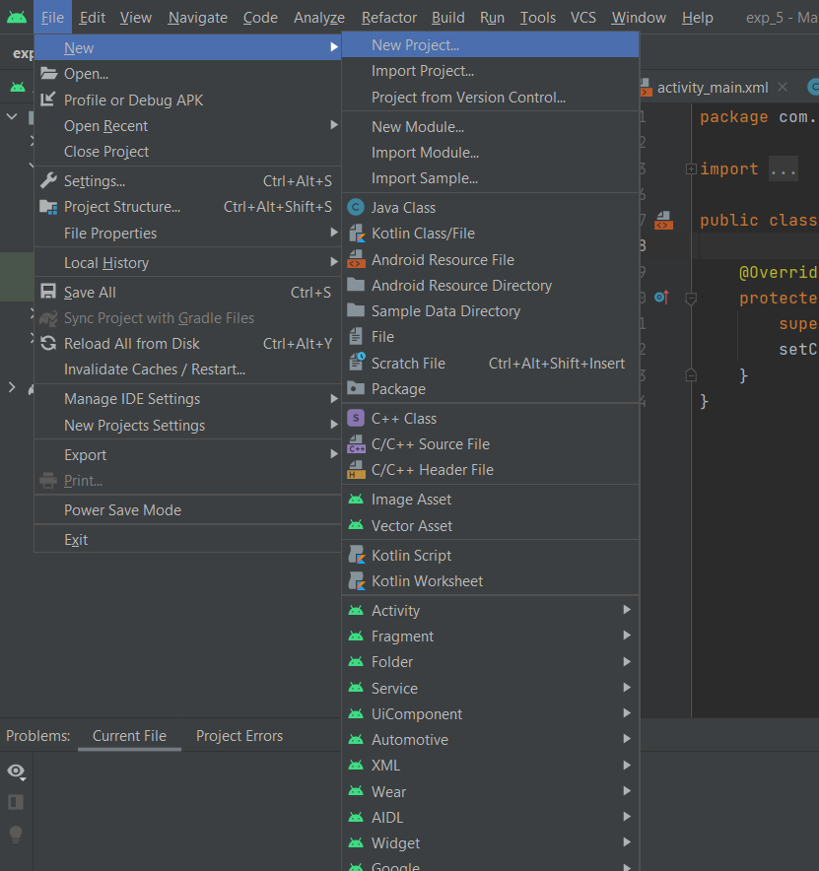Create a new project. Go to the **FILE->NEW->NEW PROJECT.**
2. Select **EMPTY ACTIVITY** and proceed with default settings. Click on **FINISH.**

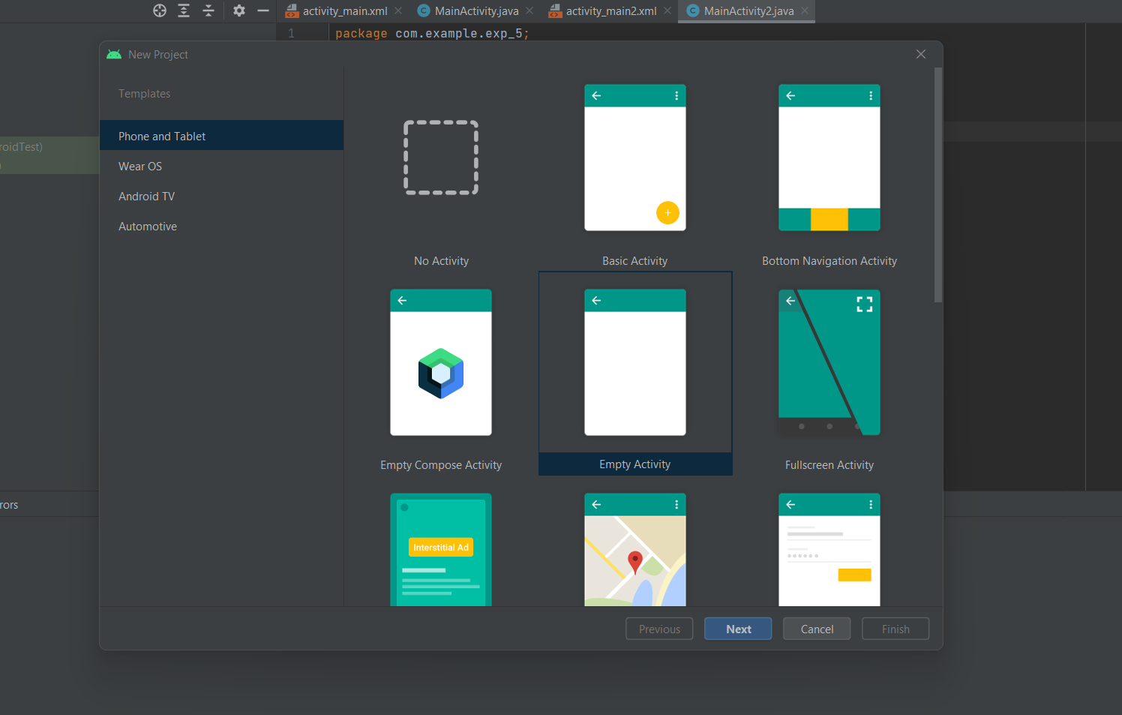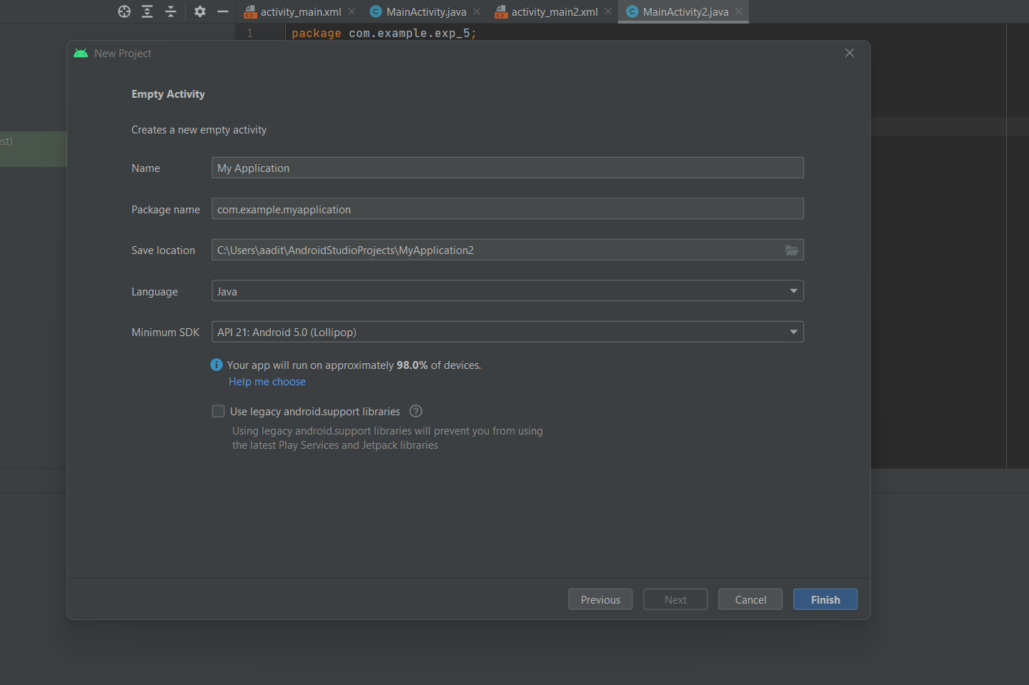

* Then type the Application name as “**ex.no.6″** and click **Next.**

**main activity java file:**

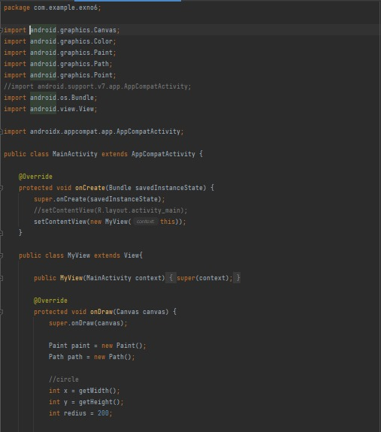

Main Activity Java (contd.):

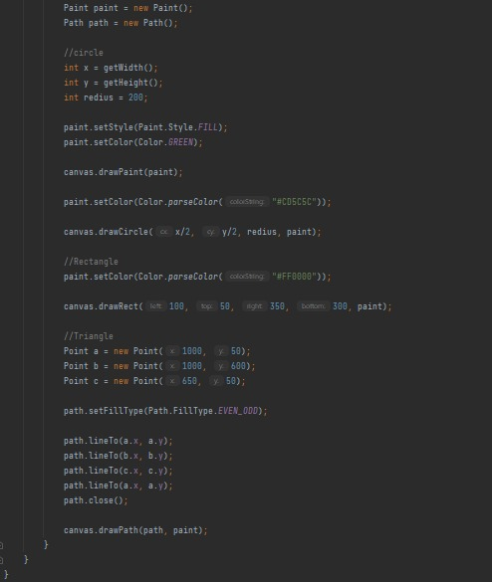

Main Activity XML

